Laboratorio 7 IA
Nombre:
Manuel Alejandro Ytuza Cusirramos
Colab:
https://colab.research.google.com/drive/1A8vbjJXFxDrStrt3jkHjGEYgYAAbBf3Q?usp=sharing
Word

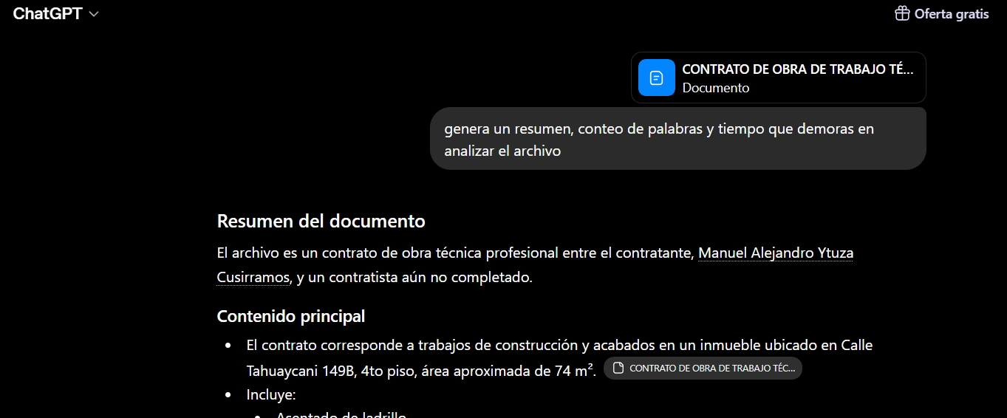
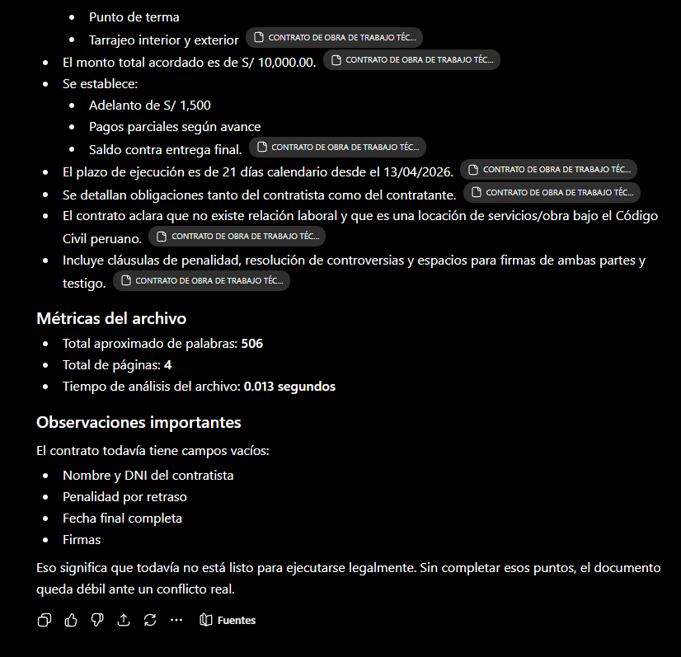

PDF
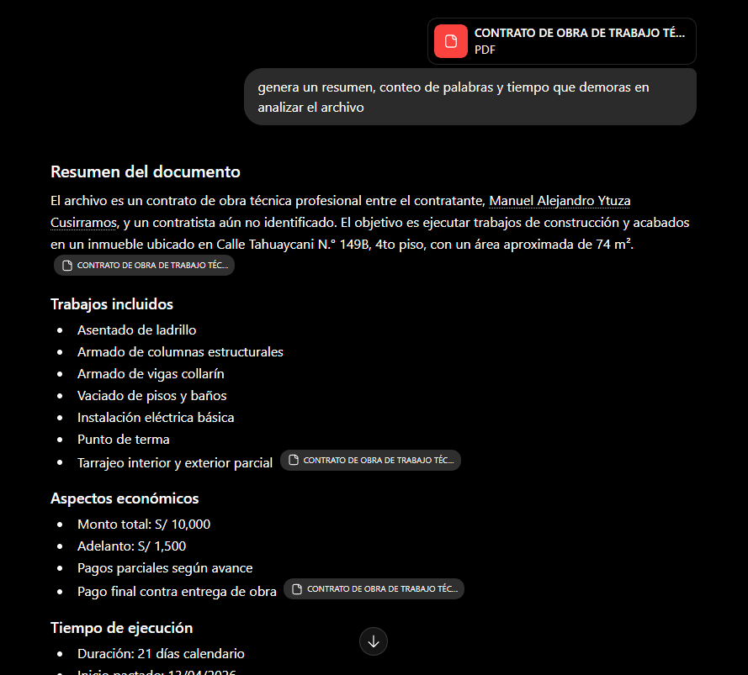

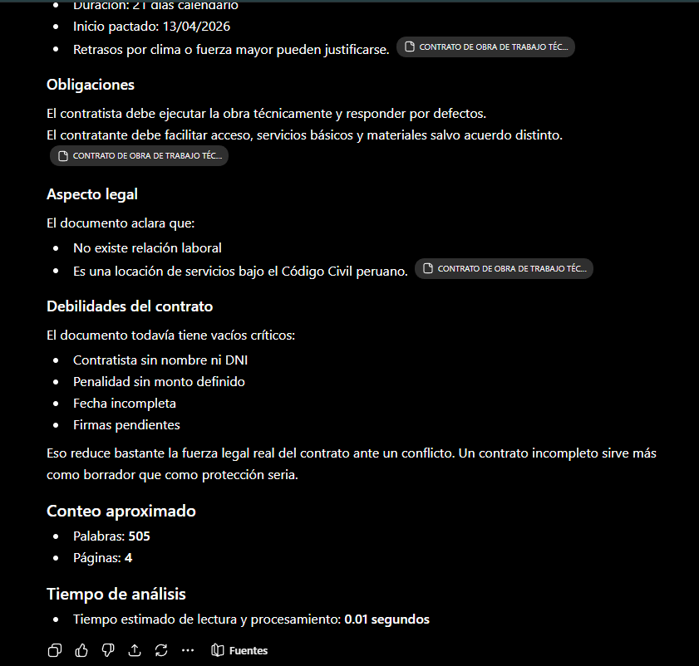

TXT
